Tricia Toffey

Data Science Bootcamp

Monday, Wednesday, Saturday

April 10, 2021

\Kickstarter is an American public benefit corporation based in Brooklyn, NY that maintains a global crowfunding platform focused on creativity. The company's stated mission is to "help bring creative projects to life". ([www.Wikipedia.com](http://www.Wikipedia.com))

"Kickstarter exists to help bring creative projects to life - film, music, art, theater, games, comics, design, photography and more". ([www.kickstarter.com](http://www.kickstarter.com))

The Kickstarter dataset includes data for projects from the last two quarters of 2009 to the first two quarters of 2017. The dataset shows the greatest number of projects for years 2014-2016 and the greatest success in the following areas:

Theater – Plays

Music – Rock and Indi Rock

Film – Documentary

Technology – Hardware

The following countries have the greatest number of successful and total projects:

United States

Great Britain

Canada

Austria

A common element shared by all of the successful projects is the “goal amount” is less than the “pledged amount”.

|  |  |  |  |  |
| --- | --- | --- | --- | --- |
| **Row Labels** | **Sum of goal** | **Sum of pledged** | **Sum of backers_count** | **Sum of Average Donation** |
| **film & video** | **$ 3,787,138.00** | **$ 4,450,684.40** | **46243** | **$ 19,595.47** |
| **music** | **$ 1,914,014.02** | **$ 2,394,997.55** | **32926** | **$ 30,068.50** |
| **technology** | **$ 5,859,808.79** | **$ 17,757,389.10** | **134238** | **$ 28,109.82** |
| **theater** | **$ 2,845,978.00** | **$ 3,147,751.29** | **39032** | **$ 56,032.81** |
| **Grand Total** | **$ 14,406,938.81** | **$ 27,750,822.34** | **252439** | **$ 133,806.59** |

The following chart shows the unsuccessful projects in the foregoing areas[1]:

|  |  |  |  |  |
| --- | --- | --- | --- | --- |
| **Row Labels** | **Sum of goal** | **Sum of pledged** | **Sum of backers_count** | **Sum of Average Donation** |
| **music** | **$ 105,780.00** | **$ 20,462.32** | **290** | **$ 849.91** |
| **theater** | **$ 3,468,821.00** | **$ 186,206.70** | **2784** | **$ 16,889.33** |
| **Grand Total** | **$ 3,574,601.00** | **$ 206,669.02** | **3074** | **$ 17,739.24** |

Also see the Bonus Chart on the following page.

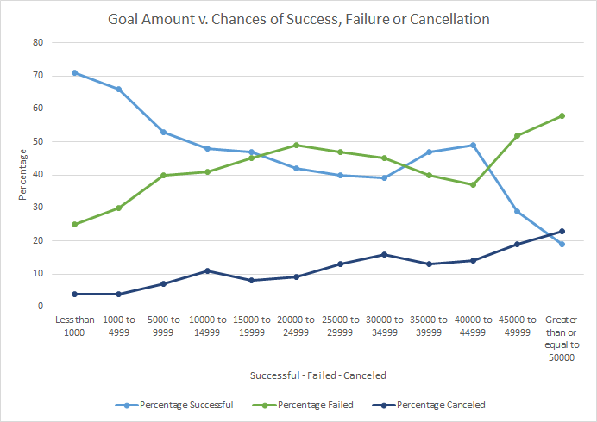

When you launch a project also seems to be a variable worth considering. Based upon the chart below, it appears that more successful projects were launched during the months of March to July and December.

Limitations of the dataset

For new projects, it might be helpful to know the number of backers from the project website on Kickstarter vs. the number of backers brought in by the individuals and the respective pledge amounts. It would also be interesting to know the current status of the successful projects.

1. Note: There were no unsuccessful projects in the Film & Video – Documentary, Technology – Hardware.